Image Processing Part II – Assignment 2

1. Why PCA is important in data and image analytics?

Principal Component Analysis (PCA) is a linear transformation that is orthogonal in nature. This minimises data dimension through conversions into a new coordinate system to interpret the less data that becomes more manageable. The transformation is designed to align the maximum variance of data onto the first coordinate called the first principal component, whereas the second principal component is the second maximum variance onto the second coordinate, these are determined by the scalar projection. Through organising an image band, the significant bands are identified to enable the best possible reconstruction of the original image that uses less data. The application entails image compression to assist the identification of cancer patients.

1. Download Figs. 11.38(a) through (f) and duplicate the sequence of operations described in the Example 11.15, including the images and tables using the main_pca.m MATLAB code.

Through Digital Image Processing textbook, the six multispectral satellite images were imported into the provided main_pca.m and created Assignment4.m MATLAB file to implement Principal Component Analysis procedure. This displays the following figures in Figure 1.

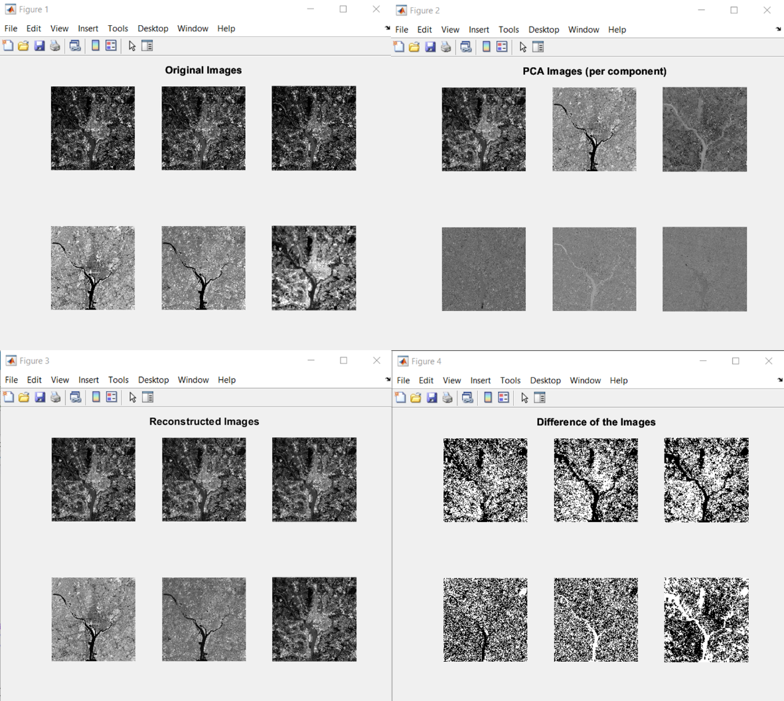

Figure main_pca.m Figures

First the program begins with the initialisation, in Figure 2, to import the six images and assign the parameters within the variables from main_pca.m.

Figure Assignment4.m Initialisation

The algorithm begins with iterations through the imported images to calculate both the mean vector and covariance matrix. Subsequently, this incorporates the eig function to compute the eigenvalues while the svd function sorts the diagonal values as a covariance matrix for Y values in Figure 3.

Figure Mean Vector and Covariance Matrix

Matrix A was taken from Q component of the eigenvalues. Through the transpose, the first to rows gives the Ak from K eigenvectors. Figure _ shows the last step is to reconstruct the image using the full A transpose matrix which would give the exact image and then reconstruct using the AK matrix.

Figure Iterations to Reconstruct X_hat Vector

1. Calculate the mean square error and Peak Signal-to-Noise Ratio in the recovered set of images by retaining only the 1) best 2, 2) best 3 and 3) best 4 principal components. Explain your results.

To display the mean square error between reconstructed images obtained through the Ak matrix to exact reconstructed image. In addition, this computes the Peak Signal-to-Noise Ratio (PSNR) that signifies the discrepancy of an image. A higher PSNR value indicates lower errors, whereas a superior PSNR values emphasises the need for a reconstruction.

Figure Calculation for MSE and PSNR with Results Tables Display

This generated the result within the command terminal in Figure 5.

Figure Command Window Output